Azure AirFLow Capstone Exercise -1
--Yadhav raj D

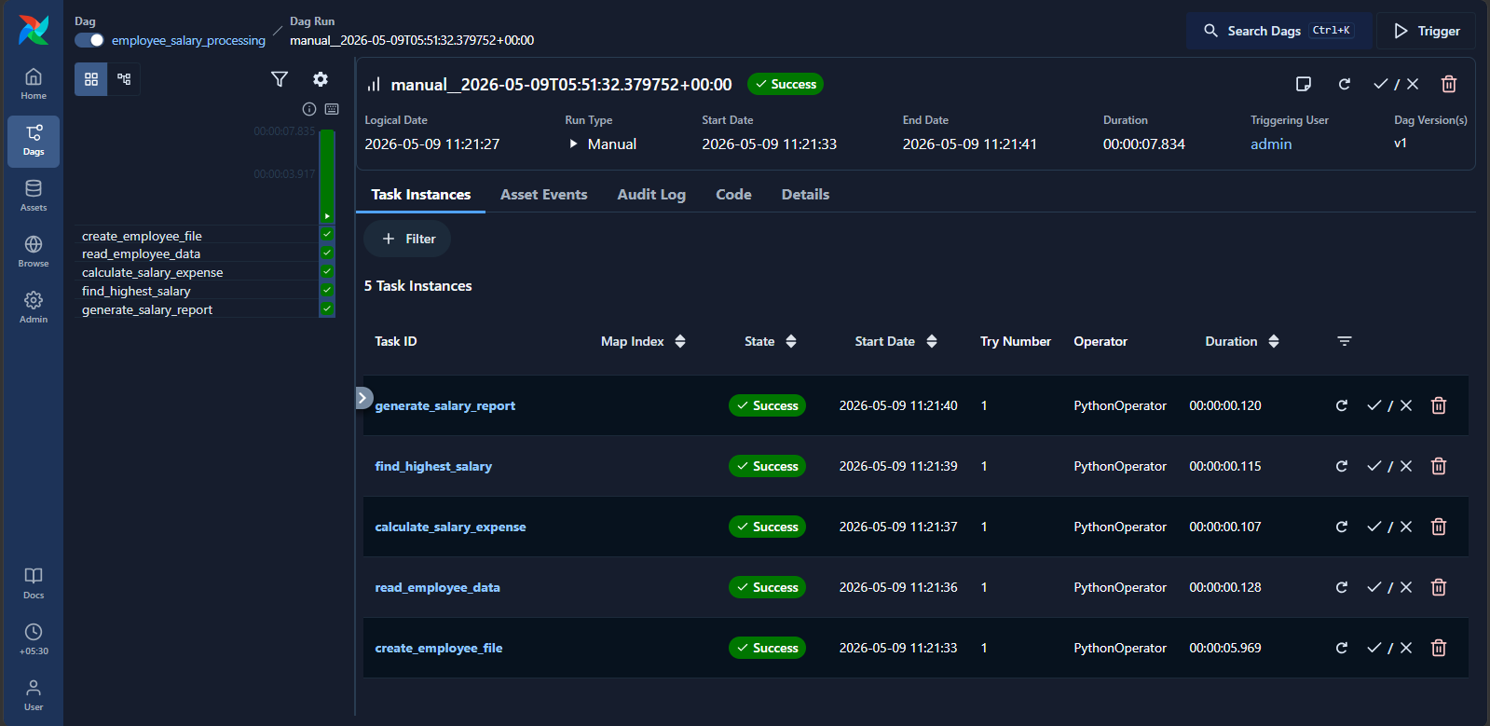

Code:
from airflow import DAG
from airflow.operators.python import PythonOperator
from datetime import datetime

def create_employee_file():
f=open("/tmp/employees.txt","w")
f.write("Rahul,45000\nSneha,52000\nAmit,61000\nPriya,47000\nKiran,39000")
f.close()
print("File created")

def read_employee_data():
f=open("/tmp/employees.txt","r")
for line in f:
print(line.strip())
f.close()

def calculate_salary_expense():
total=0
f=open("/tmp/employees.txt","r")
for line in f:
parts=line.strip().split(",")
total=total+int(parts[1])
f.close()
print("Total Salary Expense =",total)

def find_highest_salary():
max_salary=0
emp=""
f=open("/tmp/employees.txt","r")
for line in f:
name,sal=line.strip().split(",")
sal=int(sal)
if sal>max_salary:
max_salary=sal
emp=name
f.close()
print("Highest Salary =",max_salary)
print("Employee =",emp)

def generate_salary_report():
f=open("/tmp/salary_report.txt","w")
f.write("Employee Salary Report\n")
f.write("Total Employees = 5\n")
f.write("Total Salary Expense = 244000\n")
f.write("Status = Processed Successfully\n")
f.close()
print("Report generated")

with DAG(
dag_id="employee_salary_processing",
start_date=datetime(2025,1,1),
schedule=None,
catchup=False
) as dag:

t1=PythonOperator(task_id="create_employee_file",python_callable=create_employee_file)
t2=PythonOperator(task_id="read_employee_data",python_callable=read_employee_data)
t3=PythonOperator(task_id="calculate_salary_expense",python_callable=calculate_salary_expense)
t4=PythonOperator(task_id="find_highest_salary",python_callable=find_highest_salary)
t5=PythonOperator(task_id="generate_salary_report",python_callable=generate_salary_report)

t1>>t2>>t3>>t4>>t5

